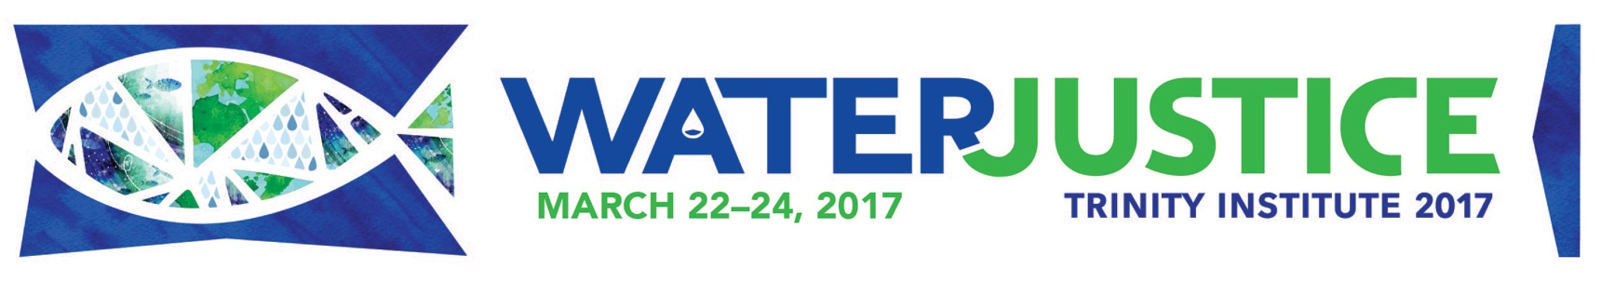 **You’re invited to attend Trinity Institute,** an annual conference that takes place in New York City and at partner sites around the country via webcast, including at **Oblate School of Theology**.

**Oblate School of Theology**

*in partnership with*

Compassionate San Antonio

Join the water justice movement! We’ll develop a deeper appreciation for water as a sacred gift, gain a thorough understanding of the relationship between water justice and climate change, and learn what we can do about water issues of access, pollution, drought, and rising tides.**ALSO FEATURING:** Christiana Peppard (Professor of Theology and Author of *Just Water*), Maude Barlow (*Blue Planet Project*), and others

**DETAILS:**

**WHERE:** **Tymen Hall at Oblate School of Theology**, 285 Oblate Drive, San Antonio, TX 78216

**WHEN:** March 22 – 24, 2017

March 22: Opening Worship livestreamed at 7pm. Keynote at 8pm.

March 23-24: 9am – 5:30pm

**COST:** **$45** – includes snacks and lunch on Thursday and Friday. 20% discount for groups of 5 or more.

*Wednesday evening only: FREE and open to the public.*

**REGISTER:** [**www.OST.edu**](http://www.OST.edu) **or call Brenda at 210-341-1366 ext. 212**

**ON-SITE COORDINATOR:** Victoria B. Luna, 210-341-1366 ext. 325 or [vluna@ost.edu](mailto:vluna@ost.edu)

**For more information about Trinity Institute’s nationaL THEOLOGICAL CONFERENCE**—including speaker bios, schedule, videos, and more—visit **TI2017.org**